
Tool Sale Feb 6TH – 10TH
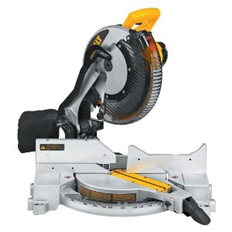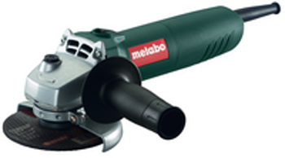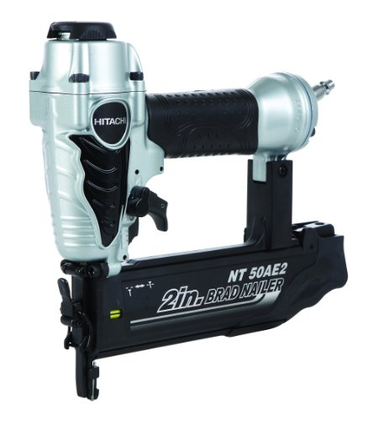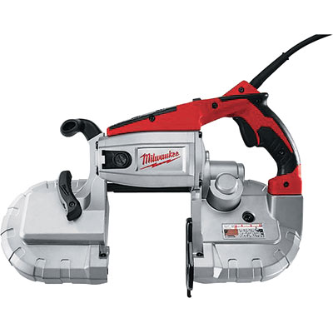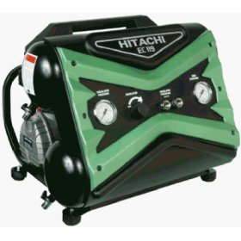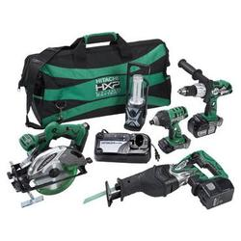
5 Days ONLY!!
Discounts On
New Tools

Plus much, much, more!!
Dewalt Mitre Saw $297

Metabo Grinders
up to 15% OFF
Hitachi Brad Nailers
$89 - $139
Regular $129 - $259
Hitachi reconditioned tool kits from $259.00
Compressors $100 OFF
Milwaukee
Band Saw
NOW
$219

